// Amazon | Online Assessment 2019 | Min Cost to Connect Ropes

// <https://leetcode.com/discuss/interview-question/344677/Amazon-or-Online-Assessment-2019-or-Min-Cost-to-Connect-Ropes>

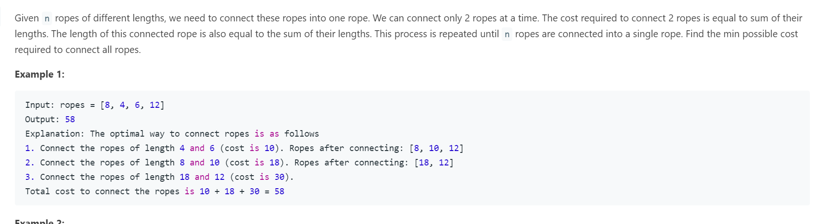

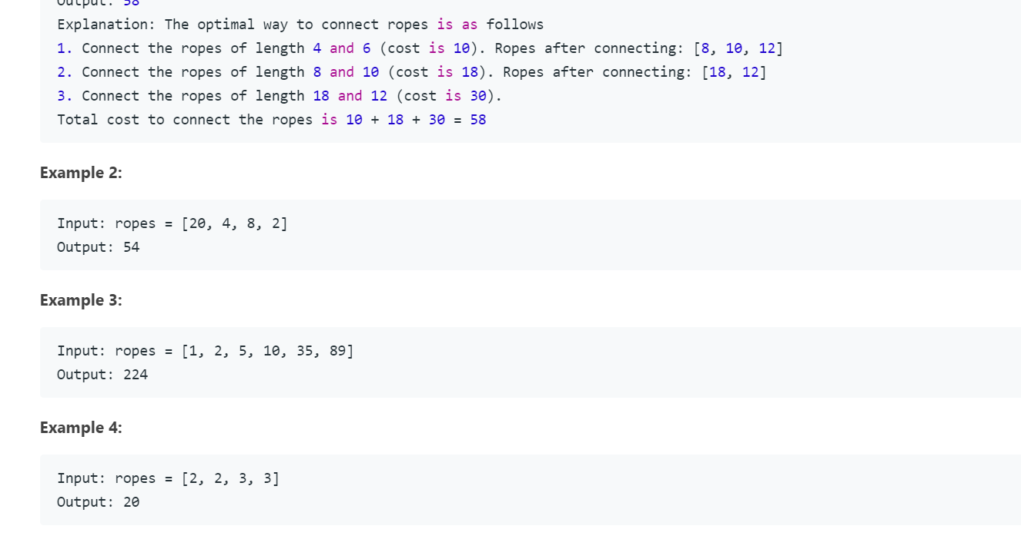

public class Main {

private void printArray(int[] A){

System.out.print("[ ");

for(int i: A) System.out.print(i + " ");

System.out.println("] ");

}

public int connectRopes(int[] ropes){

int len = ropes.length;

if(len == 0) return 0;

PriorityQueue<Integer> pq = new PriorityQueue<>();

for(int rope: ropes) pq.add(rope);

int costs = 0;

while(pq.size() > 1){

int rope1 = pq.poll();

int rope2 = pq.poll();

int ropeNew = rope1 + rope2;

costs += ropeNew;

pq.add(ropeNew);

}

return costs;

}

public static void main(String[] args) {

Main main = new Main();

int[][] testcases = {{8, 4, 6, 12},

{20, 4, 8, 2},

{1, 2, 5, 10, 35, 89},

{2, 2, 3, 3}};

for(int i = 0; i < testcases.length; ++i){

main.printArray(testcases[i]);

System.out.println(main.connectRopes(testcases[i]));

}

}

}